**Title of work:** Inventory Module Lab

**Name :** Shani Patel

**Section Code:** NEE

**Date submitted:** 23/06/2021

**Professor's name:** Tevin Apenteng

Class Diagram

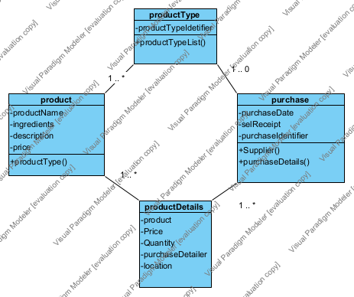

1. **Create Product Information**

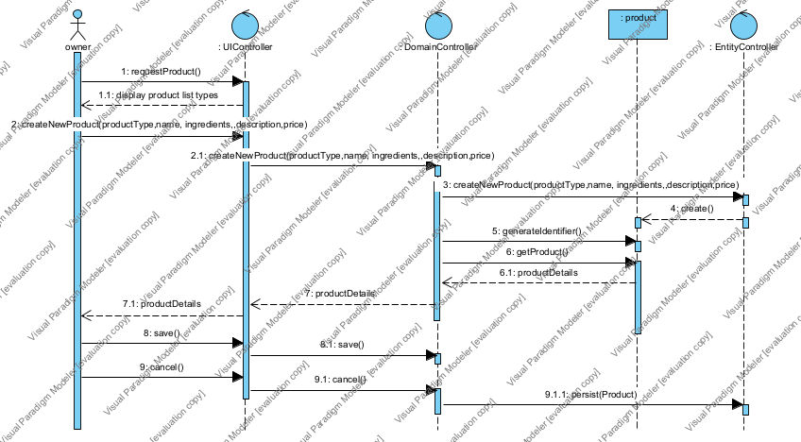

1. Query Products by Product Type

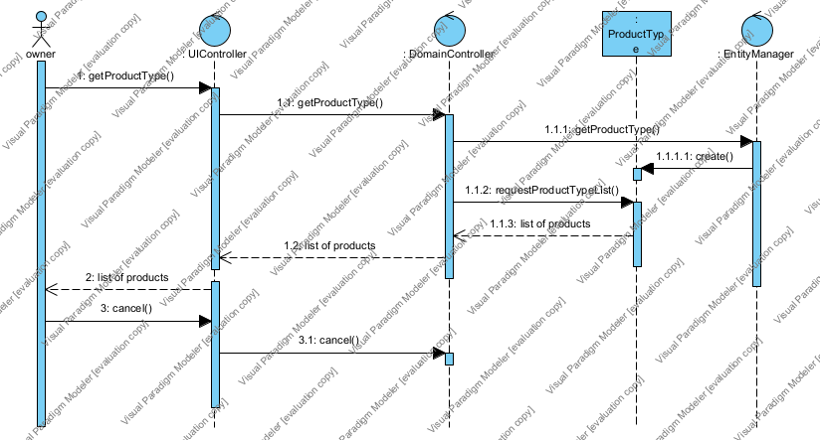

1. Create Purchase

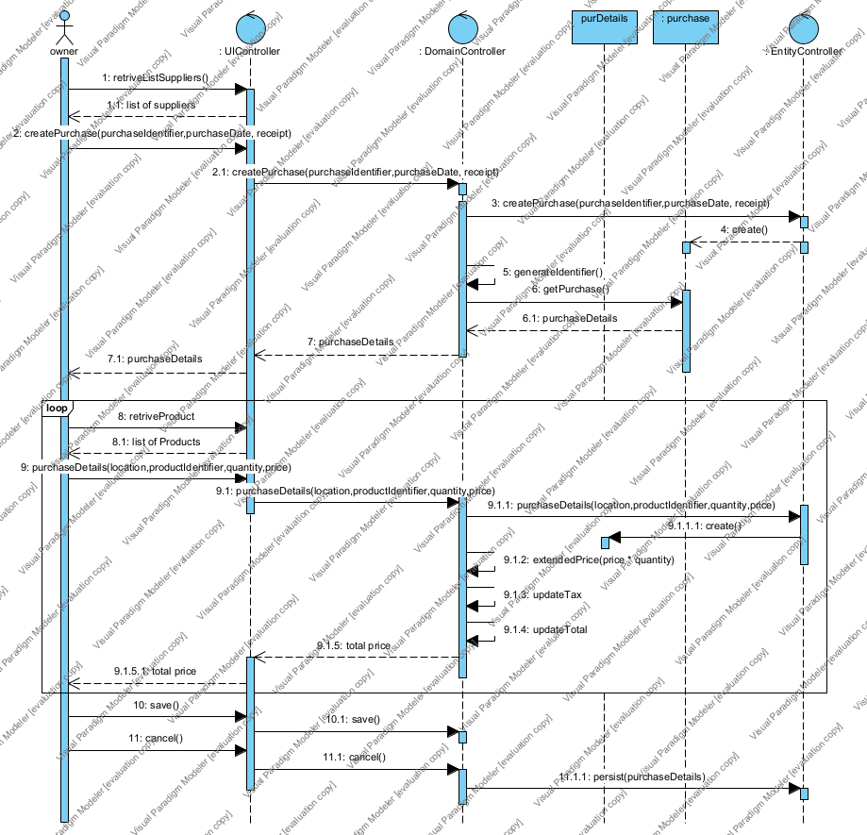

1. Query Purchases

